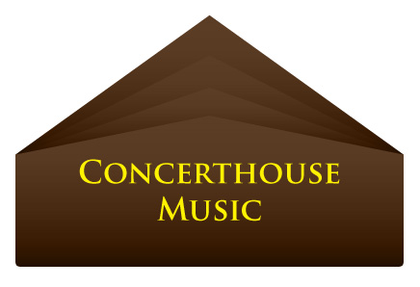

PRESS RELEASE - EFFECTIVE IMMEDIATELY – 15th May 2012
Kim Germaine signs to Concerthouse Music!

Kim Germaine has been involved in the Niagara music scene for many years. She plays a Hagstrom 12 string acoustic. Kim has not only been performing steady for the last 10 years, after taking an 8 year break from live performance to raise her son, but has also put many hours into the recording studio, learning every aspect of the music business.

Kim's first CD, "A Slice of Life", released in 2000, has done well in "off the stage" sales. Brian Gagnon of Toronto is currently producing Kim’s second CD “What Comes Around, Goes Around”.

Kim is a go-getter who has worked very hard to establish a reputation of reliability and consistency with not only the business aspect of her band but also with the level of musicianship she chooses.

She has recently been signed to Concerthouse Music as she steps up to her next musical platform.

Kim’s new EP came out in May of this year and features 5 electric guitar oriented rock tracks, with her powerhouse rock ‘n’ rock vocals as a stand out feature.

You can download and listen to her music on iTunes at www.itunes.apple.com/au/album/kim-germaine-ep/id526818582

For more information on Kim Germaine visit her MySpace page at: www.myspace.com/kimgermaineband
Or check her out on Sound click: www.soundclick.com/bands/default.cfm?bandID=161150

*************************************************************
ABOUT CONCERTHOUSE MUSIC:
www.concerthousemusic.com
Concerthouse Music is a label that works to ensure the development and nurturing of its artists business models through its ability to provide connectivity to over 600 digital retail stores and over 100 mobile platforms and operators.
With a specialized focus on marketing strategy, lives performance, touring advising and support infrastructure for their artists, CEO Ross Tonkin and his team, work to develop a unique program suited to each of their talented musicians.
Concerthouse artists include: Jessy Tomsko, Paul Cresey, Kara Mack, Earth and the Next Society, and David Juliet
Search on “ Concerthouse Music “ in Google for more information.

************************************************************************

Contact Details:
Media and Press Manager

Concerthouse Music
Unit 20 No 112 McEvoy Street
Alexandria NSW 2015
P: + 61 2 9310 0155
F: + 61 2 9310 0166
E: pr@bluepie.com.au
W: www.concerthousemusic.com/
Concerthouse Music is a Blue Pie Productions and Blue Pie Label partner and distributed by Blue Pie for the world.

